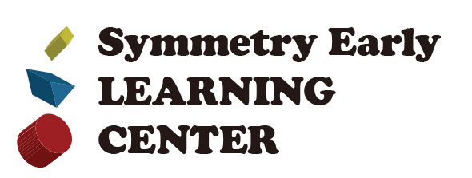

**Permission to Photograph**

From time to time, we may take photos of the children during the day. If parents give permission to release these photos, we will email them to you and/or post them on our website. Please indicate below if you give permission for your child’s photo to be taken and/or shared.

 I give permission for my child, _____________________________to be photographed at Symmetry Early Learning Center.

I give permission for copies of these photos to be shared with the other children.    
  
Yes ___    No ___

Photos of the children will also be added to our website, with permission of parent/guardian.  The photos could be side- face showing, or distance, with face not showing.

I give permission for photos of my child to appear on Symmetry Early Learning Center’s website.    
   
Yes ___ No ___

_______________ ___________________ _____________

Child’s name Parent’s signature Date

**C:\Users\user\AppData\Local\Microsoft\Windows\Temporary Internet Files\Content.IE5\M3BB7348\MC900070860[1].wmf"Play is the work of children” Friedrich Froebel**