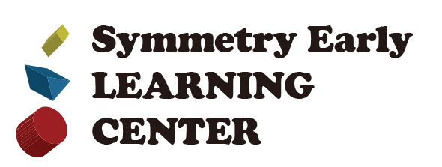Parent Handbook 2023-2024
Policy

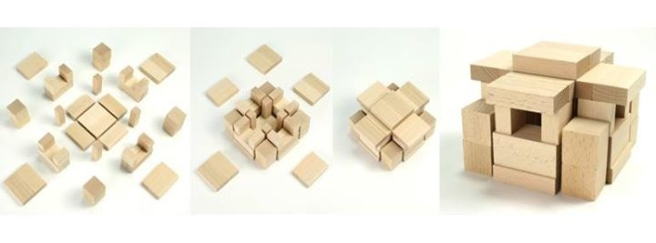
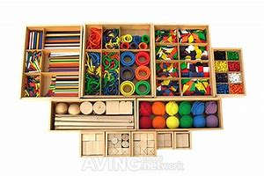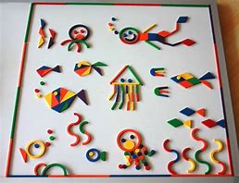
www.symmetryearlylearningcenter.com
I read it and follow it.
Name: Signature:
Date:
Please return it after signing. Thank you!

- Gabe Philosophy / Gabe Program
- Curriculum & Program /
Yearly/Monthly/Weekly Theme
- Age group development
- Daily Schedule
- Discipline Policy
- Arrival & Departure/Release of a child
- Meals & Snack
- Supplies & Equipment
- Nap &Rest time
- Illness & Medication
- Emergency Situation
- Toys from home / Screen Time
- Fee & Withdrawal
- Hours of operation & Closures
- Gradual Entry
- What to bring “Checklist”
- Monthly Theme

You may have heard the term “Kindergarten” however have you ever wondered about its origin?
Friedrich Froebel, a German philosopher and educator invented the first Kindergarten, or Garden of Children, in 1837. Froebel held the belief that children learned best through guided play and tangible, hands on experience. He believed that each child at birth possessed their full educational potential. In addition, an appropriate educational environment was necessary to encourage the child grow and develop to their full potential. His philosophy included the idea that children need to be active learners.
Froebel labeled his approach to education as “self-activity”. This idea allows the child to be led by his own interests and to freely explore them. The teacher’s role, therefore, was to be a guide rather than lecturer.
Froebel developed a series of Gabe for use in kindergartens that were designed to stimulate learning through play activities accompanied by songs and music. Modern educational techniques in kindergarten and preschool are much indebted to him. Each child experiences a delightful educational journey through play. Unique ideas, stories and reflections are drawn out from the child by way of specially designed balls, blocks, sticks, rings, and beads. These objects make up "The Froebel Gabe (gifts)". Gabe toys are thought to be the world's first educational toys. They certainly were the first materials designed for child development, as Kindergarten was the original preschool method. Directed Gabe play is used to support each child in his/her activity so that the learning process is creative and meaningful.
The Froebel philosophy creates a safe atmosphere for children to express their creative ideas and to be granted the time to follow through with them.
Teachers are able to get to know each child individually due to the small class size.
Children who take pleasure in learning do well within the Froebel environment. These children then encourage one another and discover one another’s strengths. They take pride in their own accomplishments and don’t feel the need to compare themselves to others. The children gain a sense of their own learning styles, strengths and weaknesses. Through the Froebel philosophy, each child will be given the tools needed in order to make a difference in the world and live a life that is fulfilling and rewarding.

Gabe 7

 | Lesson
1Gabe | Solid- The nature of balls, the nature of colors, the nature of  numbers and directions.
2Gabe | Solid- The shapes and nature of a sphere, a cube and a cylinder.  The principle of the turn
3Gabe | Solid- The studies of the equals, vacant positions and patterns.
4Gabe | Solid- The studies of the patterns and repetitions.  (Make vanes with various faces of the rectangular prism)
5Gabe | Solid- The study of the triangular prism. Receive the figures- a  square, a triangle, a rhomboid, a trapezoid, a pentagon and a hexagon.
6Gabe | Solid- The varieties and combinations of the Greek architecture.
7Gabe | Surface- Receive the figures- a square, triangle.  Expansions, constitutions and actual objects with the  figures.
8Gabe | Lines- Straight lines, curved lines, angles, lengths and numbers.
9Gabe | Point- A beauty and patterns of rings.
10Gabe | Frame work for solid- The relation among the dots, lines, faces and  solids.

Please find more information in our monthly newsletter!

We provide an excellent, well-rounded program for children from the ages of 30months to 5years.

Section 1-Indoor Active Activity: Big and small muscle development
- Yoga/ Morning Stretch
- Blocks
- Role play
- Music and movement
- Social
- Imaginative and dramatic play

Section 2- Wet Activity: Artistic development
- Art and Craft
- Play dough, mud projects
- Water and Sand Table
- Cooking & Baking

Section 3-Quiet Activity: Cognitive development, Language development
- Gabe
- Puzzles
- Pre-math Identifying and forming shapes, numbers and colors
- Pre-reading, recognizing and forming letters
- Matching cards

Section 4- Creative Interacting Activity
- Circle time
- Show and tell
- Science
- Games
- Storytelling

Section 5-Outdoor Activity
- Exploring nature and neighborhood
- Playground and parks
- Tossing, catching, walking, jumping, balancing, running
- Sand /Water play
- Games
- Field trips

- Toddler (1.5-3 years)
At the end of the first year of life, infants become toddlers. Between ages one and three, physical growth slows as toddlers learn to master motor and communication skills.

18 Months Old
- Social and Emotional Development: Mommy and Daddy are likely still a toddler’s favorites at this age—and he’s probably showing a lot of affection toward the people who care for him. That also means your toddler continues to be clingy. “Stranger danger” is completely normal and developmentally appropriate at this age.
- Language and Communication Development: Your child’s vocabulary should be expanding, and by 18 months, he might know up to a dozen words or more. In addition, by a year and a half, your child might be speaking in simple two-word sentences. Finally, expect your toddler to be able to point out what he wants.
- Cognitive Development: Make-believe and pretend, while not fully developed yet, will begin to show up in your toddler’s play at a year and a half. For example, you may see your toddler pretend to feed a baby doll. Your child will also be able to identify objects by pointing, including parts of his body. And, your toddler should be able to follow simple directions, like “pick up the crayons.”
- Movement and Physical Development: At 18 months old, toddlers are on the move, all the time. Your toddler should be walking on his own, and may even be running and going downstairs. He’ll also likely be able to help dress herself. And toddlers will begin to feed themselves with a spoon and should be drinking from a regular cup.

2 Years Old
- Social and Emotional Development: Your toddler is continuing to become more social and independent. And, while they still won’t interact with other kids while playing, your child probably gets excited when other kids—of any age—are around. Two years old also marks the beginning of tantrums for most kids who are learning how to express themselves when they are frustrated, upset, tired, or hungry.
- Language and Communication Development: Your 2-year-old is now speaking in longer sentences—up to four words in some cases. That's not surprising considering he knows up to 50 words and is likely learning new ones every single day. But you'll need to start being careful of what you say: Your toddler is listening and will likely repeat you at inopportune times, which can make for some embarrassing situations.
- Cognitive Development: Your toddler’s play is continuing to become more creative—you might see him making up stories or games to play. He’s also sorting items by shape and color and following more complicated directions that include two steps like, “Pick up your toys and put them in the basket."
- Movement and Physical Development: Running, climbing, throwing, kicking—your 2-year-old’s gross motor skills are on display on a regular basis. You can also expect your toddler to be able to hold a pencil or crayon and copy lines and circles.

- PRESCHOOLERS (3 to 4 years)

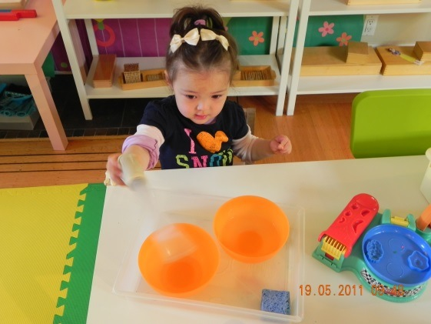

- Motor Skills Development — outdoor group games, dancing, movement, and sport
- Cognitive Development — puzzles, games, identifying and forming shapes, numbers, colors
- Language Development — recognizing and forming letters, story time, speech, finger play, writing skills
- Imaginative Development — arts and crafts with various material, dramatic play, storytelling, concerts and holidays presentations
- Social Development — large and small group activities, sharing, cooperation
Preschoolers are like sponges – they soak up knowledge. Our curriculum helps them to be ready socially, emotionally and cognitively for the next stage of their lives.
- PRE-KINDERGARDEN (4 - 5 years)

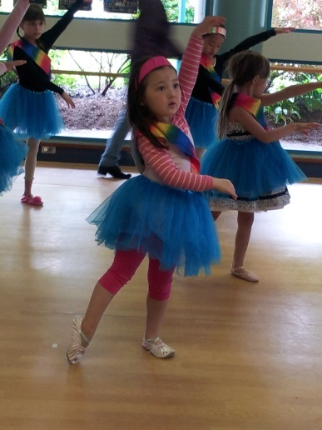

Kindergarten Prep — letters, words spelling, numbers, early science, math concepts, logical thinking, writing
- Imaginative Development — arts and crafts, dramatic play, storytelling, puppets theater, concerts
- Social Development — interaction, cooperation, helping others
- Physical Development — indoor and outdoor play, games, dancing, sport
Getting ready for kindergarten is exciting and we want your child to stay excited about learning. The Center’s teachers increase the focus on math, science, language and social studies, but we make sure it is presented with a lot of fun. Our curriculum helps children develop the critical thinking and problem-solving skills they’ll need to succeed in kindergarten, school and life. Teachers plan lessons to deepen understanding of basic academic concepts through exploration, investigation and play.

“Children are like tiny flowers: They are varied and need care, but each is beautiful alone and glorious when seen in the community of peers.” Friedrich Froebel (1782-1852)

7:30 Center open

7:30 – 8:50 Children begin arriving,
GABE, preschool workbook activities and free play

8:50 - 9:10 Clean-up, washroom

9:10 - 9:40 Yoga, Morning exercise

Circle time (weekly theme basis), weather, calendar
Music class (Wed), Show &Tell (Thu), Library
Presentation (Fri)

9:40 -10:10 Snack time and story time

10:10 -10:40 Art class

10:40 -11:20 Washroom, Outdoor Playtime

11:20 -11:45 Lunch time and story time

11:45 - 1:30 Naptime begins & quiet activities

1:30 - 2:00 Finish artwork, Symmetry workbook- letters &numbers

2:00 - 2:40 Afternoon Snack time and story time

2:40 - 3:30 Outdoor playtime

3:30- 5:00 Self-reading time, Symmetry workbook, floor activities and

free play as children are picked up by 5

5:00-5:30 Cleaning, preparing lessons /activities for the next day

We recommend your child stay with us not more than 8hours if possible.

We treat children with respect and dignity at all times. Our job as teachers is to ensure that your child enjoys and makes the most of his or her day at Symmetry Early Learning Center.

Children are just beginning to learn how to interact with the world beyond home. We encourage children to solve problems themselves but are ready to assist if necessary. The tools we use in supporting good behaviour management are; praise, respect, positive redirection, active listening, and fair consequences for behaviour. Appropriate limit setting, positive reinforcement, and consistency go a long way in helping to give children a good start in learning to manage their behaviour.
The main rule at our center is “Treat yourself, others, and the things around you with respect”. If a child is a threat to others or the property around them, a cool down period (Take a break) may be used. At times a child may display harmful or inappropriate behaviours. The child is asked what happened. A clear explanation as to why a specific behaviour is inappropriate is given. The child will then sit with the teacher for a few minutes, during which time they will discuss what appropriate action could be taken the next time. Children will never be disciplined if they have an accident (spills, bathroom accidents etc.), only encouraged to help clean up. There will never be any form of spanking or hitting used in our center.
We strive to provide a predictable, consistent, and secure routine and environment in the center in order to lessen the occurrence of inappropriate behaviours. However, if a child exhibits serious behaviour issues, we will discuss the situation privately with parents. (biting, swearing, kicking, aggressive behaviour etc.) If there is no noticeable change in the child’s behaviour towards the other children after reasonable attempts or the staff find themselves in physical danger, then the child will no longer be able to attend the center. (CCLR Section 51 Behavioural Guidance)

Behavioral guidance
51 (1) A licensee must
(a) ensure that behavioral guidance is appropriate to the age and development of the child who is receiving the guidance, and
(b) provide to employees and parents a written statement of the licensee's policy on behavioral guidance.
(2) If the child has a care plan that includes instructions respecting behavioral
guidance, the licensee must ensure that
(a) any behavioral guidance given to the child is consistent with those instructions, and
(b) if the behavioral guidance includes the use of restraints, that the restraints are administered only by a person who is trained in the use of, and alternatives to the use of, restraints.

All parents are required to sign their child in/out with initials. The center is responsible for your child once you have signed in until you have signed out. The importance of this is for your child’s safety and to enable us to have your child ready when you arrive. This will limit disruption to the regular program.
You always say goodbye to your child. Please never sneak out but do try to make your goodbye briefly. The longer you take to say goodbye the harder it is for your child. We urge you to pick up your child by 5:00pm. We recommend your child stays not more than 8hours daily. They want to spend time with their family at home.

The normal procedure for release of a child is to let them go with the parent or guardian. We will not release a child to anyone besides a parent or guardian unless we have been notified of a change. A verbal notice is fine on the day, if the person is on the list of people who are authorized to pick up your child. If the person is not on your list, we must have written permission to release your child. If we do not know that person we will ask for photo identification. This procedure is done for your child’s protection. Please inform your emergency contacts and designated pick-up people so that they will not be surprised or offended. (CCLR Section 49, 50 Safe Release of children)

Parental access
49 (1) A licensee must ensure that a parent has reasonable access to his or her child while the child is in the community care facility.
(2) A licensee must not provide care to a child unless the licensee has first ensured that the child's parent or emergency contact can be readily contacted while the child is in care.

Access by others
50 If a person is identified under section 57 [records for each child] as a person
Who is not permitted access to a child, a licensee must take reasonable steps
to prevent that person from accessing the child.

The center provides nutritious healthy snacks in the afternoon every day. Parents are required to provide their morning snack and their lunch. Lunch & snacks are a daily opportunity for us to sit down together, eat, and socialize. Children are encouraged, but never forced to eat. Our menu plan follows the Canada Food Guide recommendations.
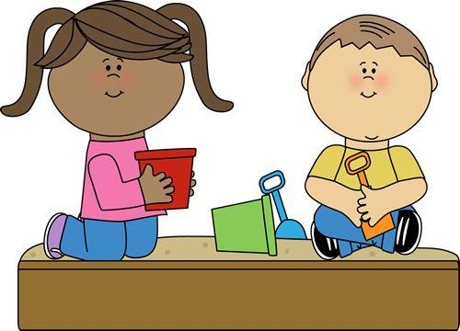
Lunch can be heated in the microwave if needed. please make sure to pack a frozen ice pack in an insulated lunch bag with a healthy food. Please do not include chips, chocolate, and candy at any time. Treats will be welcome at the center on birthdays or special events. (CCLR Section 48 Nutrition)

Nutrition
48 (1) A licensee must ensure that each child has healthy food and drink according to the Canada's Food Guide, and promote healthy eating and nutritional habits.
(2) If a child's record includes, or the child has a care plan that includes,
instructions respecting food and drink for the child,
the requirements of subsection (1) (a) do not apply to the extent that they are
inconsistent with those instructions, and (b) the licensee must comply with those instructions.
(3) A licensee must ensure that the food and drink given to a child is sufficient in quantity and quality to meet the developmental needs of the child, having regard to
(a) the child's age,
(b) the number of hours the child is under the care of the licensee,
and
(c) the child's food preferences and cultural background.
(4) A licensee must ensure that children are not
(a) fed by means of a propped bottle,
(b) forced to consume any food or drink, or
(c) left unsupervised while consuming food or drink.
(5) A licensee must ensure that safe drinking water is available to children.
(6) A licensee must make available to parents information on the food and drink given to children.
(7) A licensee must ensure that food and drink are not used as a form of reward or punishment for children.

Parents are responsible for supplying: extra change of clothing appropriate to season
- Velcro pull-ups for potty trainers & wipes (no pullup diapers without Velcro)
- Summer time-sunhat, sunscreen (no spray type) and front covered shoes
- Winter time-rain gear (muddy buddy), insulated boots and waterproof mittens
- Crib size sheet, crib size mini blanket (best size: Baby bassinet blanket)
- A pair of indoor shoes/ slippers (Nonslip rubber bottom)
- Socks all the time for the importance of hygiene and safety
- It is not recommended to wear onesies or princess dresses. It is hard for the children to manage themselves while using the bathroom or playing outside. They are very active, and we have many messy activities during their stay with us. Simple clothes that are easy to move around in are the best option!

We encourage sensory play and creativity which means that sometimes your child will get messy. Please ensure that your child comes to the center dressed ready to play. We also will be outside every day weather permitting. Please provide appropriate outer wear for the season.
All personal items (including lunch items) and clothing brought to the center must be labeled with your child’s name.

There is a naptime/ quiet reading time each day after lunch. All children must nap, read, or play quietly during this period. It helps children to ready for the afternoon activities. Please send us their favorite crib sheet and mini size baby blanket. We will wash them once a week at the center for everyone’s convenience.

According to the Fraser Health, the center must follow the following regulations.
The Regulations are for the health and well-being of all the children and enables us to provide the best possible environment for your child.

Parents must keep a child at home if he or she has a contagious illness and/or is displaying symptoms that would inhibit him or her from participating in the program. Payment is still required, even if your child is absent due to illness. Please call us in the morning or if possible the night before to tell us your child will not be at daycare. The main illnesses are:
· fever (101 F/38.3C or higher)
· vomiting
· diarrhea
· discharge from eyes and or ears
· head lice
· conjunctivitis (pink eye)
· unexplained rash
· coughing until vomiting
· child obviously unwell (excessive crying , whining or other behavior
that inhibits your child from participating in program)
· contagious illness of any sort,

We will not accept a child for care if any of these symptoms/illnesses have present within the last 24 hours. If a child displays any of these symptoms while in our care, we will contact parents for immediate pick up. Your child may return 24 hours after the temperature has returned to normal, vomiting/diarrhea has stopped or 24 hours after the first dose of an antibiotic. Your child may return to the center after the incubation/contagious period is over and he or she is well enough to carry on with the daily schedule. Your child is welcome to attend the center if he/she has a mild cold and is able to participate. If your child becomes sick with a communicable disease listed above, you must have a doctor’s note stating that your child may return to the center, before he can resume attendance in the program. There are no fee adjustments due to absence or family vacations.
Please do not administer Tylenol or other over the counter medications before drop off as it may mask symptoms of something more serious or contagious. Parents MUST fill out the administration of medication form for ANY medication administered to your child in the center. Please do not leave any medication in your child’s bag. Medication must be in the original labeled container. It is parent’s responsibility to give specific instruction in writing, including the name of the medication, dosage, and administration times. We store the medication properly and deliver it back to you at pick up time.
Please note: These guidelines must be followed in order to ensure the safety of every child in our program.

We make every effort to provide the children with a safe environment through supervision and childproofing. However, minor bumps, scrapes and cuts are inevitable. In the case that something should happen, the appropriate first aid will be given. We have current First Aid and CPR Training. If a major injury or medical problem occurs, the parents will be contacted immediately. If we are unable to contact either parent, we will call the emergency contact numbers supplied to us. If necessary, we will not hesitate to call 911 or the poison control center, prior to calling the parents. If necessary, the injured or ill child will be transported to the hospital by ambulance at the parent’s expense. All parents are responsible for completing the child’s Health Form and Consent for Emergency Treatment and Transportation.
Emergencies happen anytime, anywhere, without warning, but there are things you can do to make emergency situations a little easier to deal with. Be ready to respond to any emergency situation.
Please check the meeting areas(Parking lot or Yale Court Park) on our fire drill floor plan next to the exits.
We will be at 2550 Yale Rd (Tennis bubble facility), In case of emergency requires relocation.
Practices implementing the fire drill system once a month and Emergency plan once a year.
In the event of inclement weather please stay tuned to the local radio and television broadcast for Board of Education Closing. We will follow the same protocol for public school closing. In the event of the center emergency, you will be notified by us. (CCLR Section 22 Emergency Training and equipment)

Emergency training and equipment
22 (1) A licensee must have all of the following:
- emergency exits and a fire drill system approved by a local assistant within the
meaning of the Fire Services Act;
- an emergency plan that sets out procedures to prepare for, mitigate, respond to and
recover from any emergency.
(2) A licensee must ensure that each employee
(a) is trained in the implementation of the fire drill system and emergency
plan described in subsection (1), including the use of any equipment
noted in the fire drill system and emergency plan,
- practices implementing the fire drill system at least once each month,
and
(d) practices implementing the emergency plan at least once each year.
(3) A licensee must display a copy of the fire drill system in a prominent
place in the community care facility
(4) A licensee must ensure that all employees have access, in an
emergency, to reliable communications equipment.

First aid
23 (1) A licensee must ensure that children have at all times immediate access to an employee who
- holds a valid first aid and CPR certificate, provided on completion of a course that
meets the requirements of Schedule C,
- is knowledgeable respecting each child's medical condition, if any,
and
(c) is capable of effectively communicating with emergency personnel.
(2) A licensee must have first aid kits that are readily accessible to all employees, including while care is provided off the community care facility premises.

Limit Screen time! We will use mobile devices or laptop computers for the use of educational information look up with children.( less than 5times per year) Too much screen time can lead to attention spans, sleep and eating disorders, reading skills, the ability to play or talk with adults and other children and obesity.
Active play helps to promote healthy growth and development and supports body control and movement. Active play can help build strong bones and muscles, improve balance, coordination and assists with the development of gross motor and fine motor skills. Active play also helps to promote children’s confidence, improves concentration and thinking and learning skills and provides opportunities to develop social skills and make friends.

A $60 non-refundable registration fee and a deposit of two weeks of fee secure your space in our program. In the extremely unlikely event that a spot is not available for your child after the deposit is received, we will promptly return the deposit to you.
Fees are also payable with cash, cheques or e-transfer. Postdated cheques are appreciated.
Please send us e transfers in the last week of each month in advance if you prefer. Yearly receipts for income tax purposes will be available in January each year for the previous year.

At the time of withdrawal, the deposit can be applied to the last months fees, refunded or will be applied to any outstanding debt. The contract requires one calendar month notice (by the end of month) of withdrawal and failure to provide that may lead to an additional month fee and/or loss of deposit. If a parent changes their mind after verbally accepting a position and the child does not actually occupy the space, the deposit will not be refunded. (CCALA Section 19 Repayment Agreements)

We provide a wide variety of educational books, games and toys. I ask that children and parents leave toys at home. This ensures that your child’s toys don’t get lost or forgotten. This also reduces any problems regarding sharing a special item.
If your child has a special blanket or stuffed animal that he or she likes to sleep with or uses for comforting reasons, then your child is welcome to bring his/her special item. Show and Tell is held every Thursday. We suggest something that follows out weekly them. Your child may bring in something that they would like to share with the rest of the class. Here are some suggestions: new toy, book, stuffed animal, something that follows out weekly theme.

Our Tuition is calculated on 4 Weeks basis.
How many days in | 2.5-3  Years old | 3-5  Years old
2Days | $598  $238 | $487  $269
3Days | $857  $317 | $678  $351
4Days | $1088  $368 | $861  $425
5Days | $1303 $403 | $1030  $485
Black numbers: Tuition before Fee Initiative Reduction
Red numbers: Parents portion after Fee initiative Reduction
Payment may be made by cash, cheque or e-transfer. Cheques are made payable to the Symmetry Early Learning Center. Cash &E transfer in the last week of each month and post dated cheque for 1st of each month
-Fees remain the same regardless of absence due to statutory holidays, holidays or illness.
-Late Pick-Up Policy: The Centre closes promptly at 5:00p.m. Parents are required to notify the Centre as soon as possible, if they are unable to arrive by closing time. If a child remains in the Centre past 5:00 p.m., a late fee will be $10 for 1st 10mins and $1.00 per minute after that. Time will be calculated using clocks at the Centre. This fine is charged regardless of reason for lateness or prior notification from the parent
that they will be delayed.
-A $20 banking fee charge will be assessed for all returned checks.
-Tuition is reviewed annually. Typically, increases occur in April during renewal system. However, an adjustment can be made at any time upon 30 days notice.

Symmetry Early Learning Center is open Monday to Friday from 7:30 to 5:00.
The center is closed on statutory holidays, including:

2023: New Year’s Day (Jan 2 in lieu), BC Family Day (Feb 20), Good Friday (April 7),
Easter Monday (April 10), Victoria Day (May 22), Canada Day (July 3 in lieu), Center’s Summer Vacation (Aug 4), BC Day (Aug 7), Labour Day (Sep 4), National day for Truth& reconciliation (Oct 2 in lieu) Thanksgiving Day (Oct 9), Remembrance Day (Nov 13 in lieu), Christmas & New Year Holiday (Dec 22- Jan 4)
* We reopen on Friday Jan 5th 2024.

2024: New Year’s Day (Jan 1), BC Family Day (Feb 19), Good Friday (March 29),
Easter Monday (April 1), Victoria Day (May 20), Canada Day (July 1), Center’s Summer Vacation (Aug 2), BC Day (Aug 5), Labour Day (Sep2), National day for Truth& reconciliation(Sep 30), Thanksgiving Day (Oct 14), Remembrance Day (Nov 11), Center’s annual vacation ;Christmas & New Year Holiday (Dec 23- Jan 3)
* We reopen on Monday Jan 6th 2025.

Note: If a child is absent either due to illness, an unanticipated closure, or any other reason, tuition fees remain unchanged. In addition, part time children do not receive “extra days” to make up for the missed days.
"Parents should not fear because they do not know how to teach their children ... Let them imitate the child's example ... become children with the child, learners with the learner." ~ Friedrich Froebel

Starting child care can be a big adjustment for the child and the whole family. Even children who have been in care before need time to get to know new people before they can become comfortable in a new space. To support the child and the family through the process of adjustment and acquaintance, a gradual entry is required. The gradual entry schedule lasts approximately one week and begins with short visits, building up to a full day of care. This week is meant to help the child, the parents, the teachers and center friends to get to know one another.
Suggested schedule for the first week;
-1st & 2nd day: 9:00-11:30(before lunch time)
Water bottle, inside shoes and snack
-3rd & 4th day: 9:00-11:45 (after lunch time)
Water bottle, inside shoes, snack and Lunch
-We will discuss the following schedule after starting the first week. It depends on the
child.
We look forward to working together to provide your child with the best educational experience possible at Symmetry Early Learning Center.

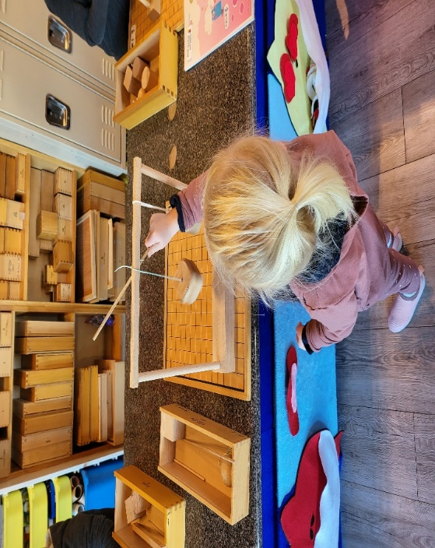 Gabe 2

- 3 recent wallet size portrait photos (1for file, 1for emergency card and student’s board). Your child should be instantly recognizable in the photo
- Registration fee-$60(non-refundable)
- Deposit- two weeks of monthly tuition
The deposit will be applied to the last month with one month notice by in the end of month
- 6months postdated cheques or E transfer in the last week of each month for the following month ex) Aug 27 for Sep tuition
- Emergency medical treatment Form and Kit (size:large ziploc 27cm x 27cm)
Family photo, poncho, (plastic rain jacket), small size non perishable little snacks, warm socks, mitten/gloves, beanie, mini fleece blanket
- Extra clothes (T -shirt, pants, socks, underwear, sweater/hoodie)
- Seasonal gear/ summer or winter
- Crib sheet & Bassinet size blanket for bedtime/quiet time
- Inside shoes - a clean pair of runners(comfortable, put on/take off shoes independently)
Your child must wear their socks everyday for safety and hygiene reasons
No onesie, No open toed shoes, No princess or tutu layered skirts!
Please all personal items (including lunch items) and clothing brought to the center must be labeled with your child’s name.

Thank you for your cooperation!

We look forward to working with your family!

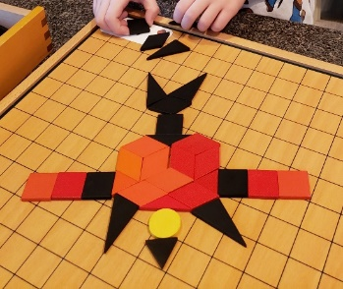

 | Theme | Learn about
January | Winter | New year, snow and ice, animals in winter
February | Valentines  Family and Pet  Friends | Family day, Valentines, Emotions, Friends ,Pet  (important of Family values, understanding our feelings,  Sharing, friendship)
March | Seasons and Weather  Space  Garden | Weather; (Wind and air, Rain, Cloud)  St. Patrick’s day, Garden  Space( Earth, Sun, Mercury, Venus, Mars, Jupiter, Saturn, Uranus, Neptune, Pluto)
April | Spring  Easter day  Insects and Birds | Frogs, Reptiles, Snakes, Butterflies and Moths, Bees  Birds( Wings, Feathers, Lay eggs), birds habitat  Easter Day and Earth day
May | Mother’s Day  Farm | Mother’s Day, Farm, Food  Plant Life-cycle, Animal Life- cycle
June | Father’s Day  Sports  Good bye School  Zoo/Jungle | Father’s day  Sports ( seasonal sports, field sports, water sports)  End of the school year, prepare for next step  Jungle and Zoo animals
July | Summer Fun 1 | Canada day, carnivals  Summer treats, pizza, berry &watermelon day,  Marine life/Sea, happy summer, the beach, Our golden sun
August | Summer Fun 2 | Bubbles day, it’s magic, rainbow day, sticky day, water, ice cream day, Camping out, Summer activities  Rainforest
September | All about me  School life | All about me, our five senses, living things, healthy food, taking care, helping others, considering others  School life, rules
October | Fall | Leaves and weather, apples, nuts, squirrels, corn, pumpkins, scarecrows, spiders, Thanksgiving, Halloween
November | Transportation  Vehicle  Jobs | Things that go; on the road, trains, on the water, in the air, types of transportation, how to use transportation  Jobs and occupations, what does he/she do?
December | Christmas  Holidays | Shines and sparkles, stars, gingerbread, cookies, toys, surprises, the nutcracker, poinsettias, Christmas

